Internship Management System (GROUP 1 PROJECT)

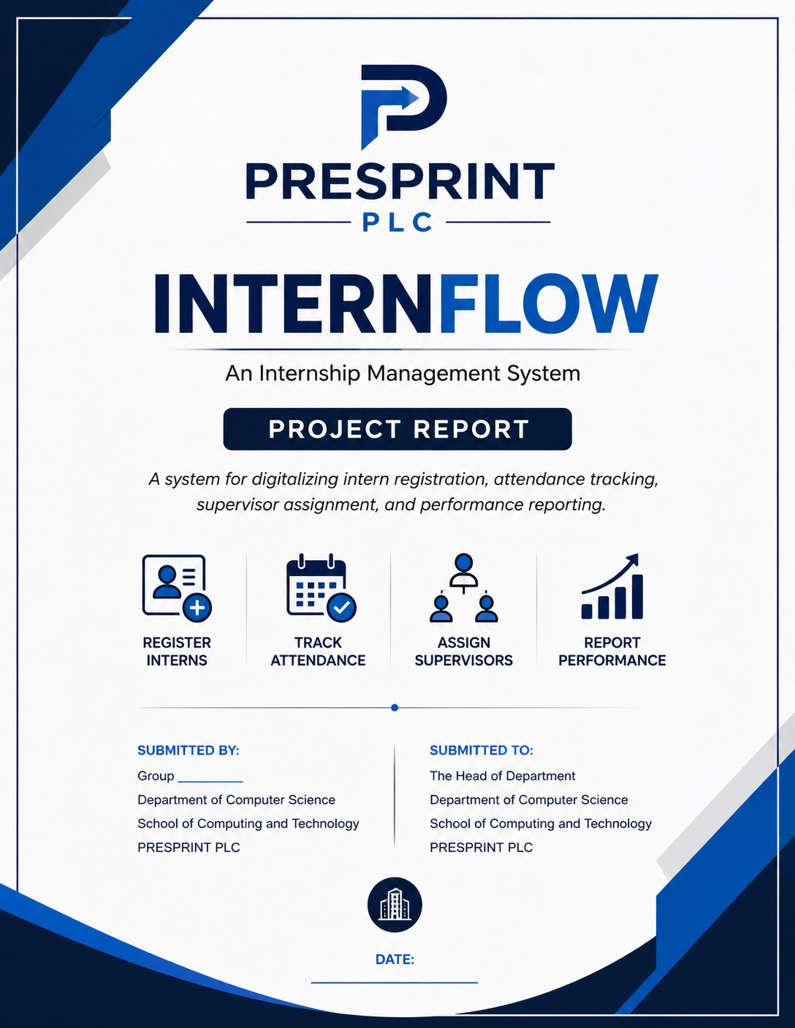
ONE
GROUP MEMBERS:
Ngene Brandon
Ngefor Marion
Nchang Vigiline

Table of Contents

Introduction
Tools 1
UML 1.1
FIG 1
FIG 2
FIG 3
FIG 4
FIG 5
Class Diagram:
ERD Explanation
HTML 1.2
CSS 1.3
JavaScript 1.4
IndexedDB 1.5
Jira: 1.6
Appendices 2
Fig 1:
Fig 2:
Fig 3:
Fig 4:
Fig 5:
Fig 6:
Fig 7:
CONCLUSION:

Introduction
At PRESPRINT PLC, internship management is currently carried out using manual methods. Interns are registered manually, attendance is recorded in paper attendance books, and supervisor assignments are communicated verbally. These processes are time-consuming, susceptible to human error, and make it difficult to efficiently store, retrieve, and monitor internship records. They also limit the organization's ability to accurately track attendance and evaluate intern performance.
To address these challenges, InternFlow is proposed as a digital internship management system. The system automates intern registration, attendance tracking, supervisor assignment, and performance reporting through a centralized platform. By replacing manual processes with a digital solution, InternFlow improves efficiency, enhances record accuracy, simplifies monitoring, and provides better support for managing internship activities at PRESPRINT PLC.

Tools
To achieve our goals we planned to use the following toll, Unified Modeling Language ( UML) HTML(Hypertext Markup Language):, CSS(Cascading Style Sheet), JavaScript, and Indexed DB(Database), and Jira Below we have detailed explanation of each tool and its significance in the system

1.1 UML
Is a standardized visual modeling language used in software engineering to visualize, specify, construct, and document the design of a system.
There are many, but we focused on two types:
Use Case Diagram: Use case diagram is the high-level bird's-eye view of how users (Actors) interact with the system to achieve a goal. Best for: Defining project scope and requirements.
Actors (Stick Figures): External entities (e.g., User, Admin).
Use Cases (Ovals): Actions the system performs (e.g., "Register", "Delete").
We Identified 5 Use Case diagrams as shown below:

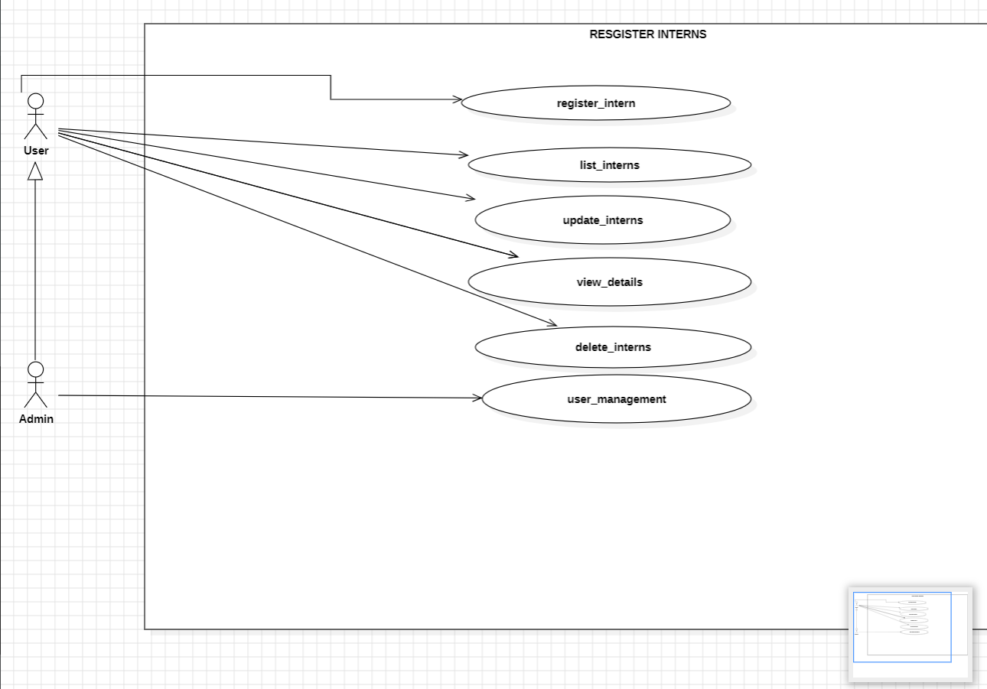
FIG 1: User can register, list, update, delete interns and also view details about interns, while the Admin has all these privileges, it can also create new interns

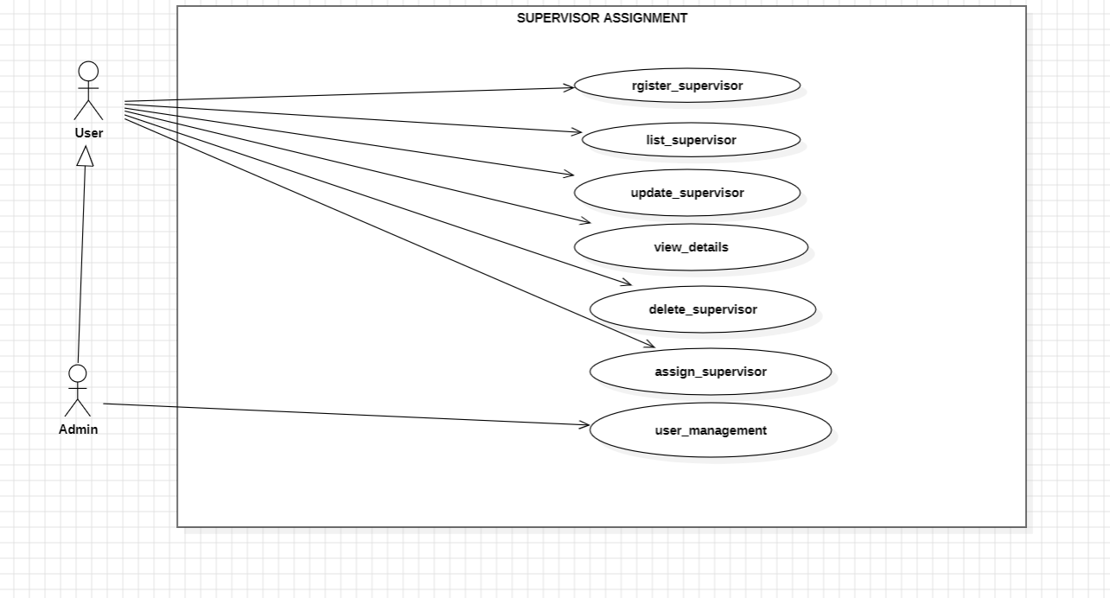
FIG 2: User can register, list, update, delete Supervisor and also view details about interns, while the Admin has all these privileges, it can also create new supervisors and Assign them.

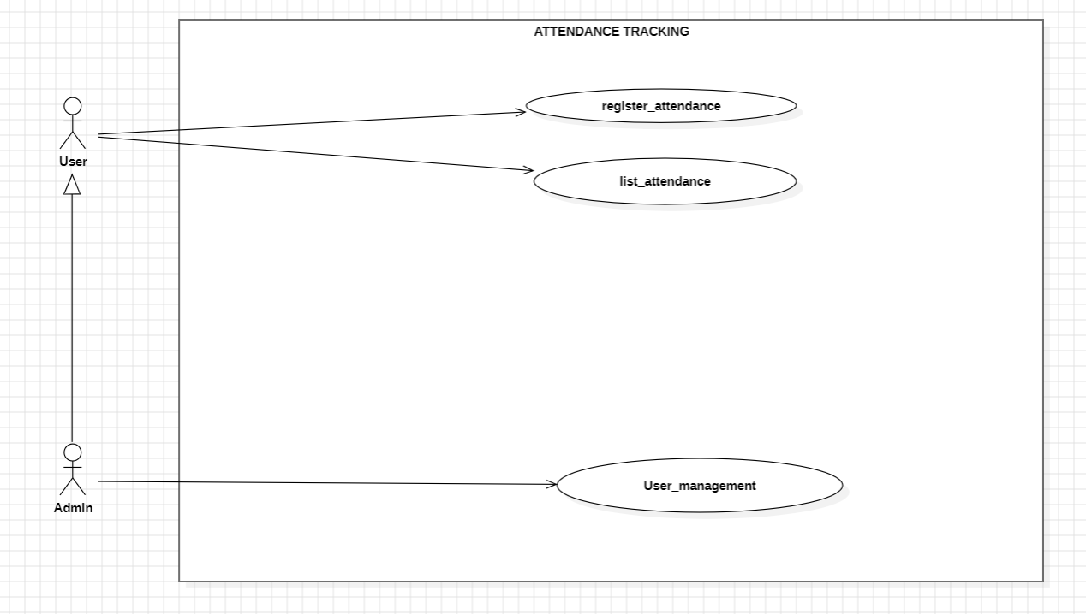
FIG 3: User registers attendance and list attendance, while Admin has all privileges, he can also create, delete attendance.

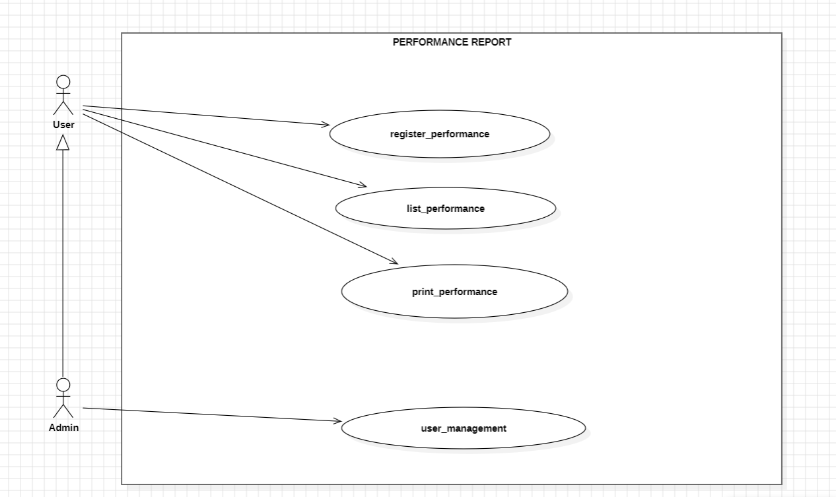
FIG 4: User can register, list, print performance. Admin can create performance, delete and also carry out all privileges as the User

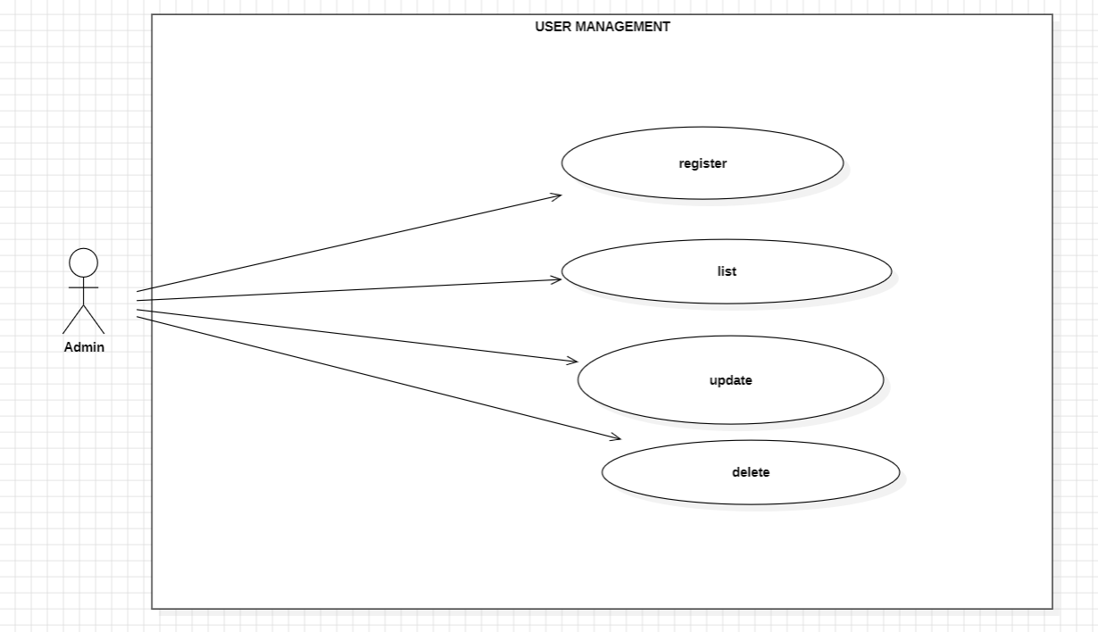
FIG 5: Admin can register/create, delete, update ,list users

Class Diagram: The backbone of object-oriented design. It models the classes in a system, their attributes (data), their methods (behaviors), and how they relate to one another.
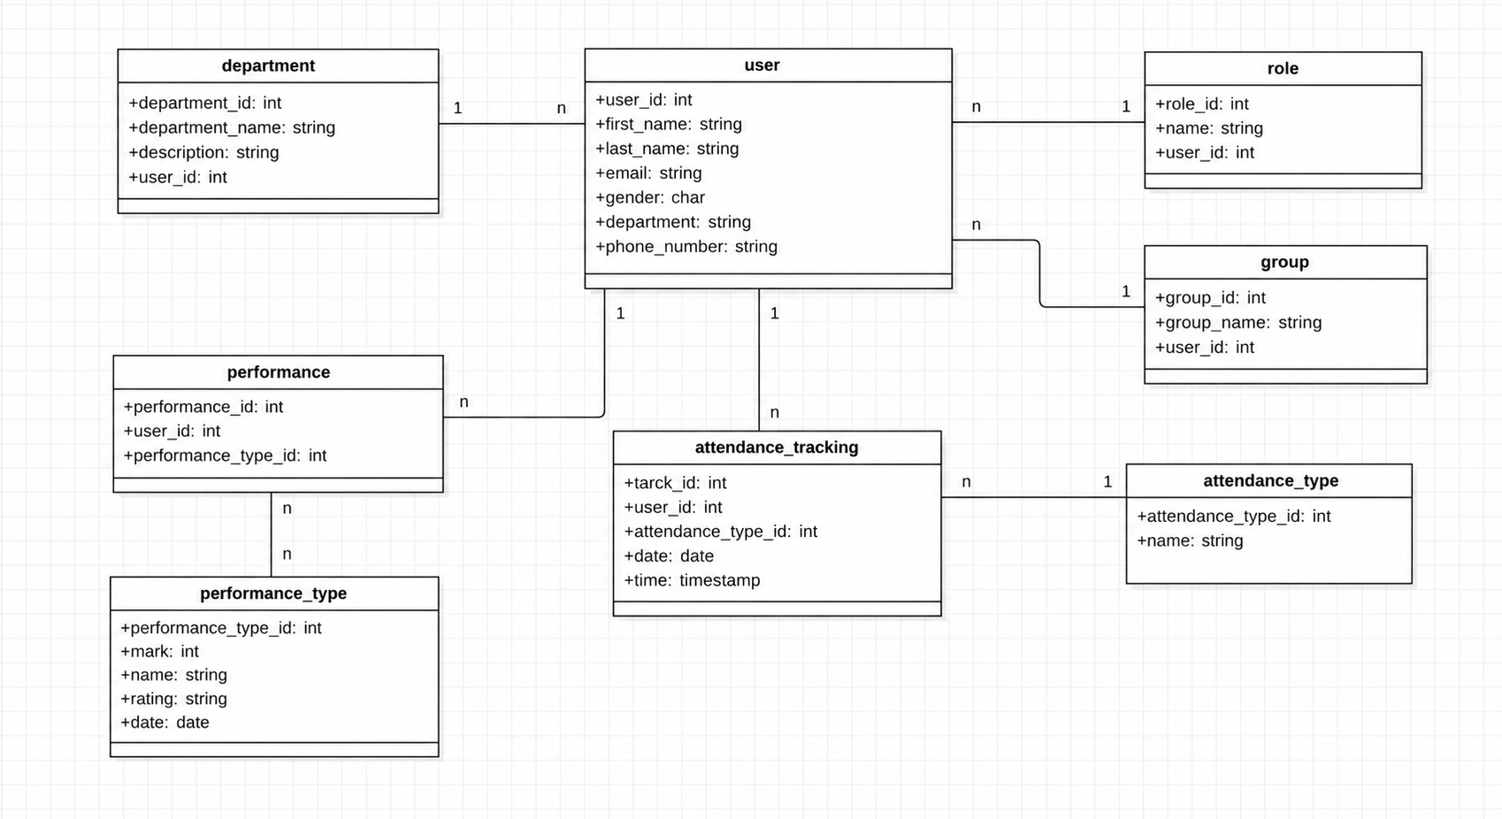

ERD Explanation
The Entity Relationship Diagram (ERD) illustrates the database structure of the InternFlow Internship Management System. The user table is the central entity, linked to department, role, and group for organizing users. The system records attendance through the attendance_tracking table, which references attendance_type, while intern evaluations are stored in the performance table and categorized using performance_type.
Cardinalities:
- Department → User (1:N): One department has many users; each user belongs to one department.
- Role → User (1:N): One role can be assigned to many users; each user has one role.
- Group → User (1:N): One group contains many users; each user belongs to one group.
- User → Attendance_Tracking (1:N): One user has many attendance records.
- Attendance_Type → Attendance_Tracking (1:N): One attendance type is used in many attendance records.
- User → Performance (1:N): One user can have many performance records.
- Performance_Type → Performance (1:N): One performance type can be linked to many performance records.

1.2 HTML: HTML is the language used to create the structure and content of web pages, this will be used create the different pages like the login, intern, supervisor, attendance, performance and setting page.


1.3 CSS: will be used to style our html pages, the buttons, icons, font sizes in order to achieve our desired design.


1.4 JavaScript: JavaScript makes websites interactive, make buttons responsive, show pop ups on click, update statistics and link frontend to backend database system.



1.5 IndexedDB: is a built-in, low-level database system that lives directly inside your web browser. It is designed to store large amounts of structured data, including files and binary large objects (blobs), and uses indexes to enable high-performance searches on that data. This will be our main database storage for this system, storing our tables, attributes and linking every table or class to each other
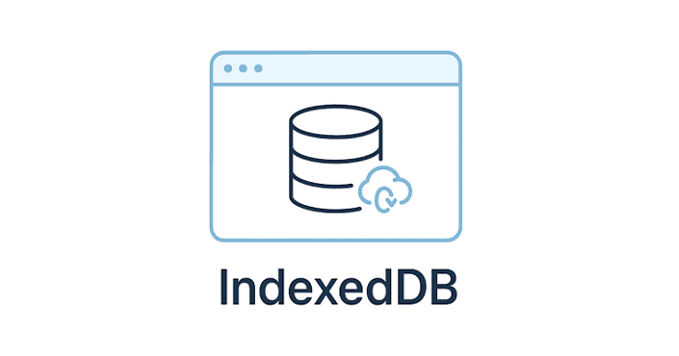

1.6 Jira:
Is a platform we used for assigning, sharing task. This will help us to efficiently split tasks within our team and be focused on specific work each day.


Appendices:
Below are snippets of our Source code and screenshots of our system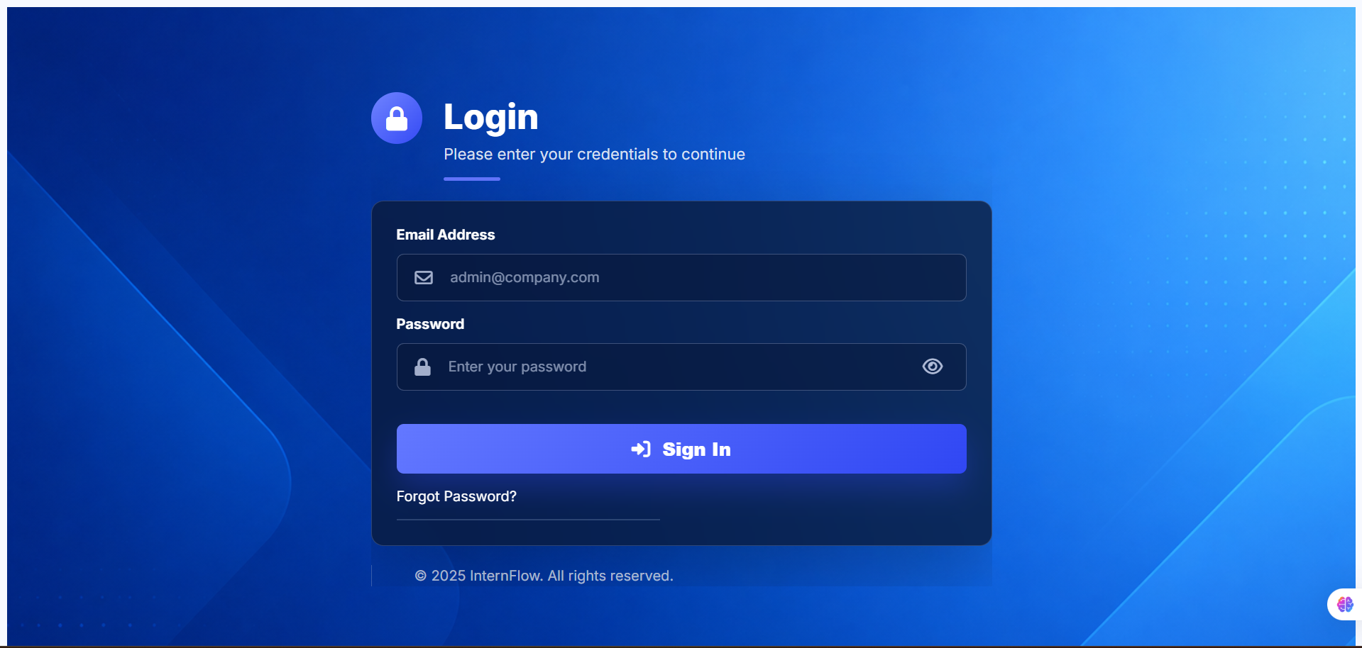

Fig 1:
Here we have the Login page, used by the admin to sign in

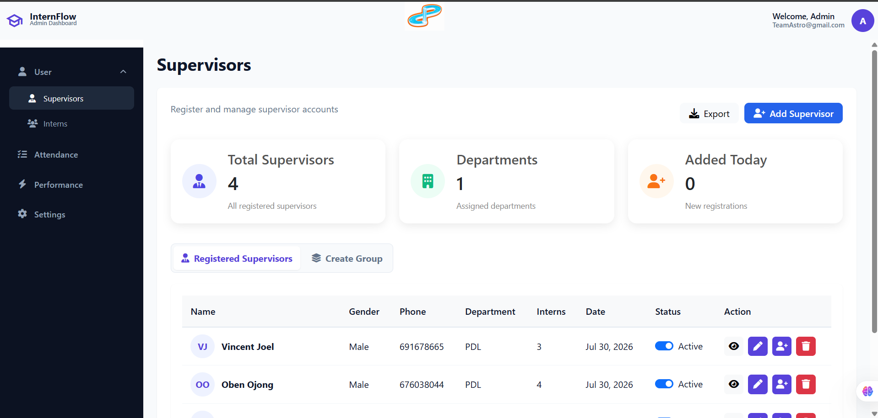

Fig 2:
Here is a screenshot of the supervisor page

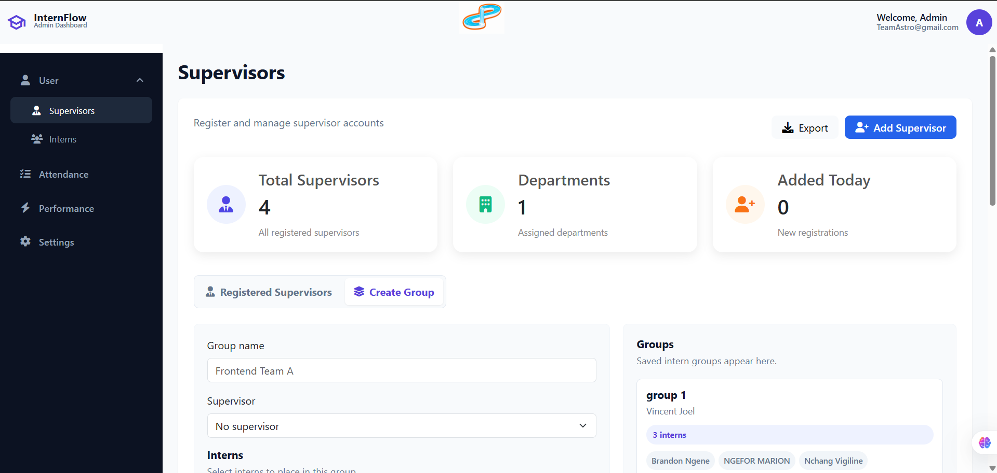

Fig 3:
This is the Create group Tab for creating groups and assigning supervisors to interns

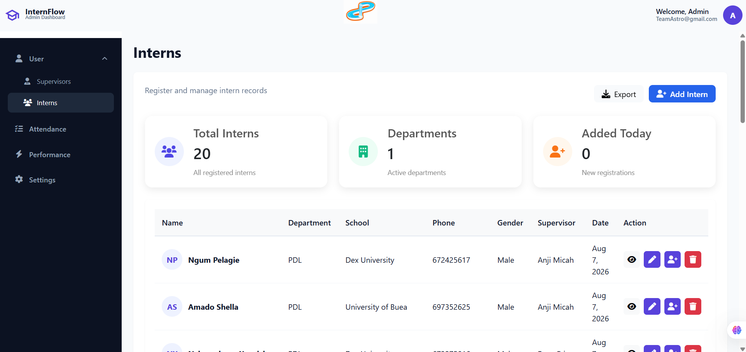

Fig 4:
Here we have the intern registration page, as well as a few registered interns for testing purposes

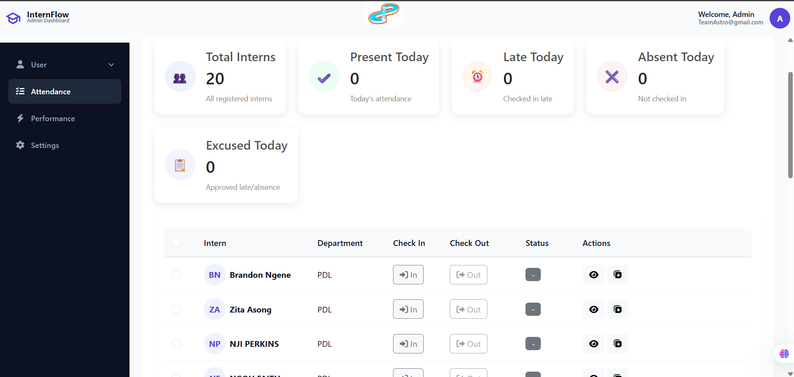

Fig 5:
Here we have the intern performance tab.
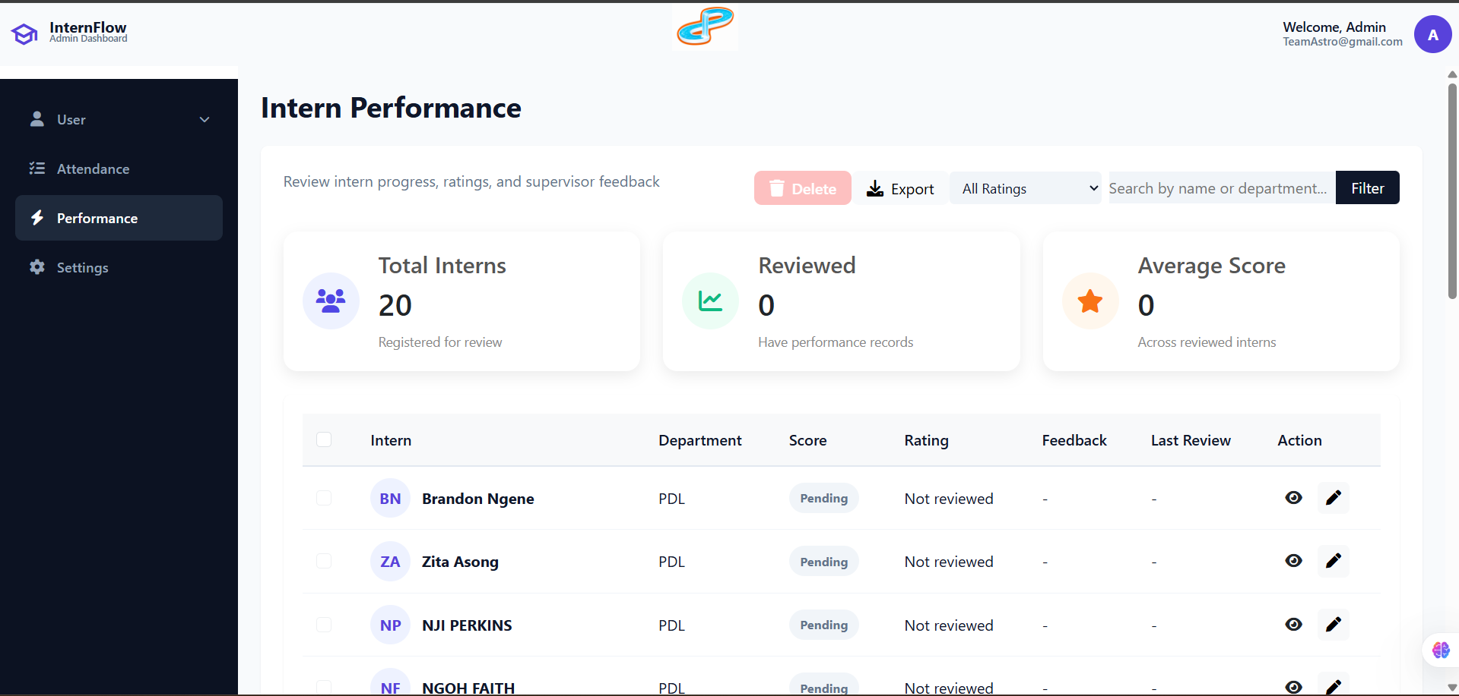

Fig 6:
Here we have the intern performance tab.

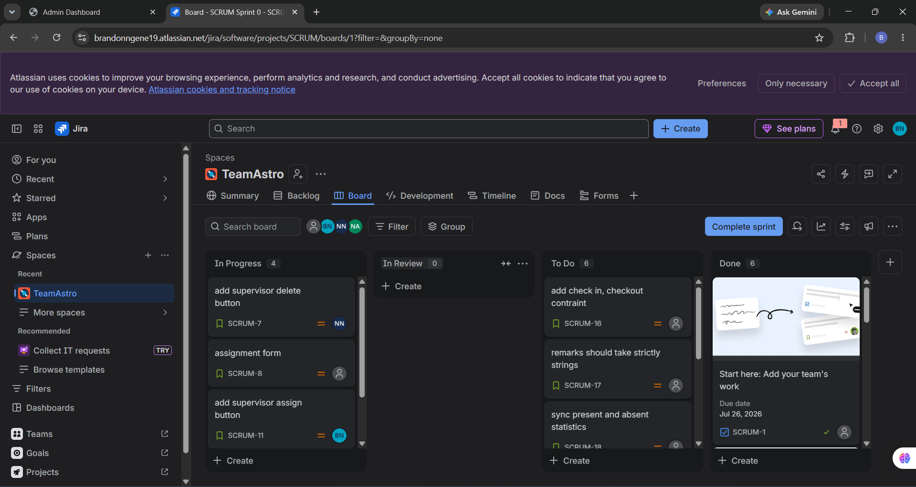

Fig 7:
Jira platform is where we share and assign projects task to each other

CONCLUSION:
In conclusion, this project shows that a full internship management system can be built using only client-side technologies, with no server required. By combining UML design with IndexedDB — the browser's built-in database — InternFlow offers fast performance, zero hosting costs, and complete data privacy, since all data stays on the user's device. Administrators can register interns, generate credentials, and process attendance records quickly and reliably, even without an internet connection. This project proves that powerful, secure, and scalable internship management tools can be built directly into the browser, opening the door for future upgrades like offline tracking, performance evaluation, and better team collaboration.

